How visible and readable do you feel each of the following are on the Application - [Link](https://app.uizard.io/p/d82ceb8b)

Ranking: 10 / 10



Comments: Very easy, clear and at the top of the screen

Ranking: 5 / 10

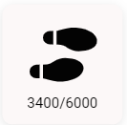

Comments: I think the text could be a bit bigger

Ranking: 5 / 10



Comments: Im not sure what Good actually means

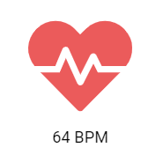

Ranking: 10 / 10

Comments: Easy to tell what this icon means and easy to read

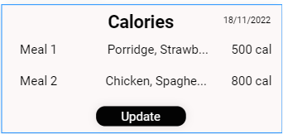

Ranking: 7 / 10

Comments: Title easy to read but text gets more difficult

Ranking: 9 / 10



Comments: Easy to read, could just be displayed higher up on screen